**.Jenkins/workspace/jobname/target**

**By default ---Jenkins user**

**Restart Jenkins using url**

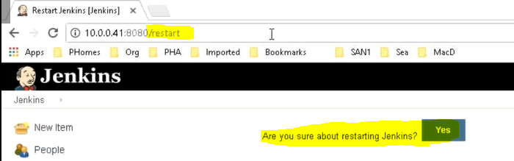

**Where the jobs are executed on the agent:**

/home/Jenkins(Remote root directory)/workspace/jobname

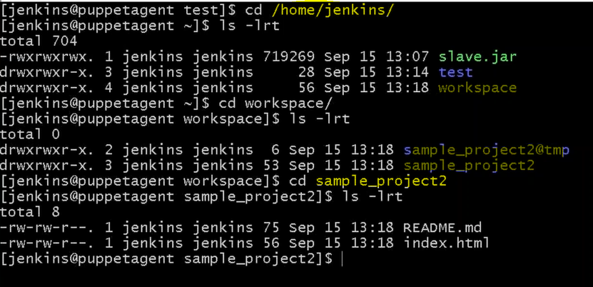

**Files from Github will be copied.**

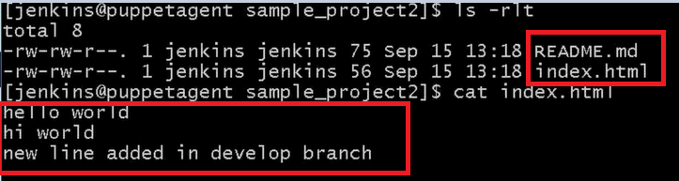

**Setup SSH Passwordless Login**

To set up a passwordless SSH login in Linux all you need to do is to generate a public authentication key and append it to the remote hosts **~/.ssh/authorized_keys** file.

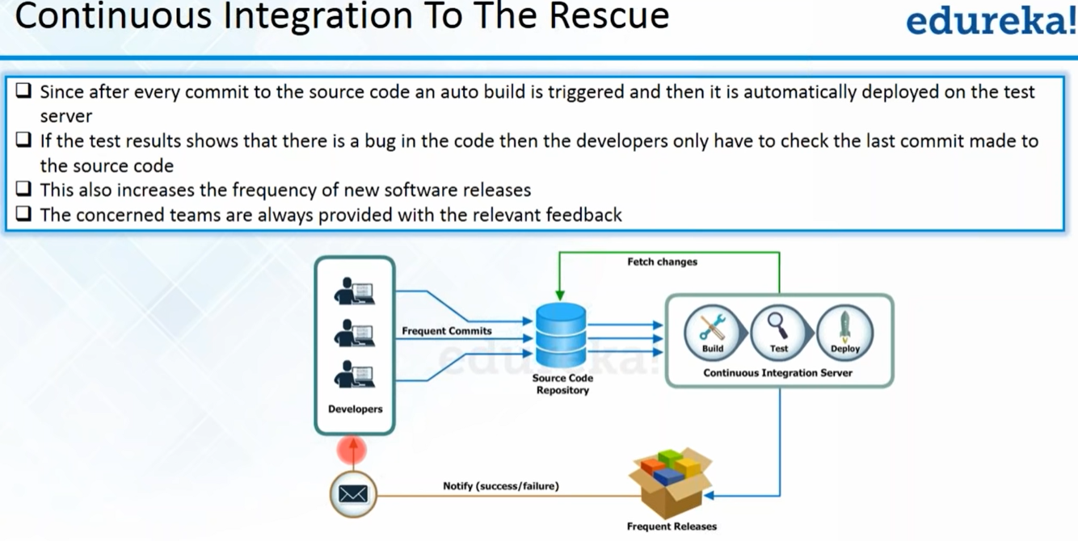

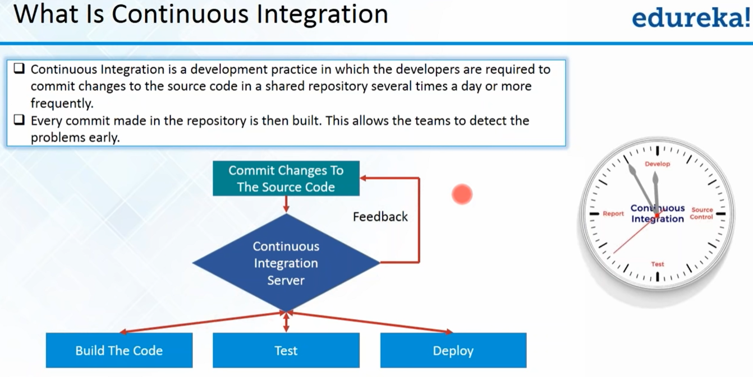

 Jenkins--Hudson

Jenkins is a free and open source automation server. It helps to automate the parts of software development related to building, testing, and deploying, by facilitating continuous integration and continuous delivery.

Flexible & more plugins

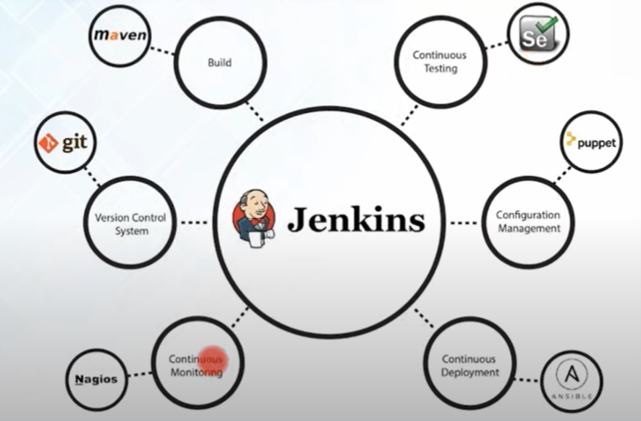

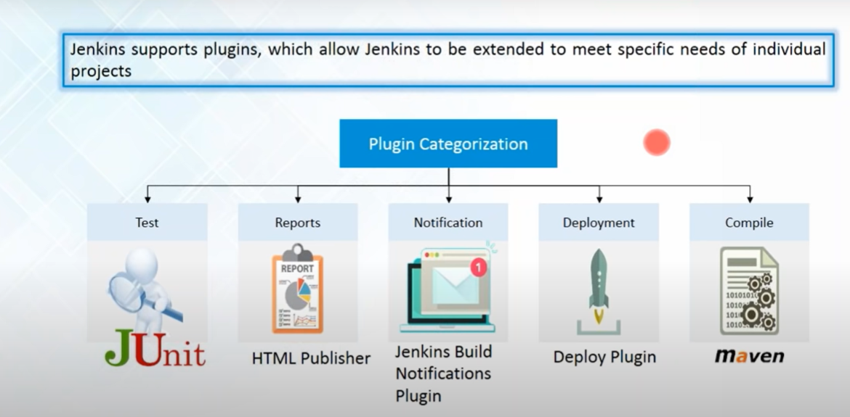

**PMD plugin** :: for review

**Pipeline view plugin:**

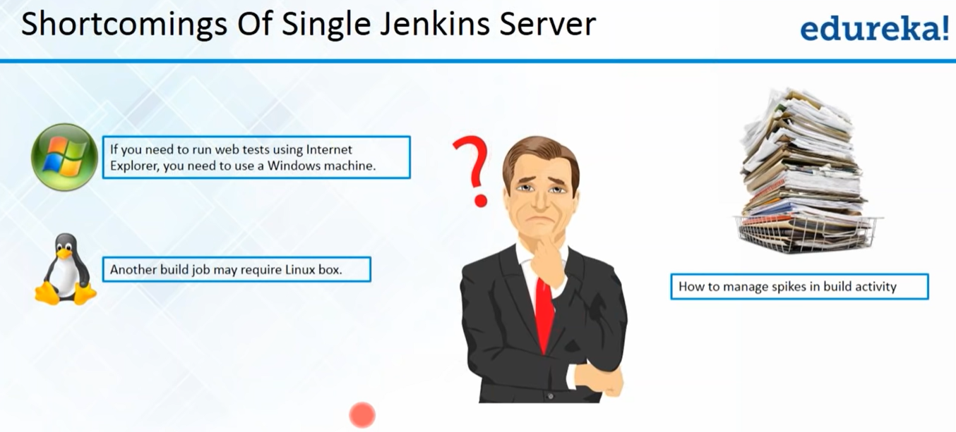

Build periodically ---It schedules a job without git commit with constant time frame ((* * * *))

Pol SCM--- triggers a job when developer do git commit

Mvn sonar-sonar(for code review/analysis)

**Hpi—Jenkins** plugin extension (

**.** Jenkins ----Backup(TO make other server as Jenkins master will copy .Jenkins folder)

Plugin’s:

1. [Role-based Authorization Strategy](https://plugins.jenkins.io/role-strategy) :: Manage and assign roles
2. Job DSL **(Pipeline DSL (domain-specific language)**

* Job DSL can be used to create Pipeline and Multibranch Pipeline jobs.
* The seed job is a Jenkins job which runs a DSL scripts, and then generates a new job.
* Job DSL was one of the first popular plugins for Jenkins which allows managing configuration as code

job('job_dsl_created') {

description('Thi is my first DSL job')

parameters {

stringParam('Panet',defaultValue = 'world', description = 'This is the world')

booleanParam('FLAG', true)

choiceParam('OPTION', ['option 1(default)', 'option 2' ])

}

scm {

git('https://github.com/Lokesh-anji/First-repo.git','master')

}

triggers{

cron('H 5 * * 7')

}

steps {

shell ("echo 'Hellow world'")

}

publisher {

mailer('L@gmail.com', true,true)

}

}

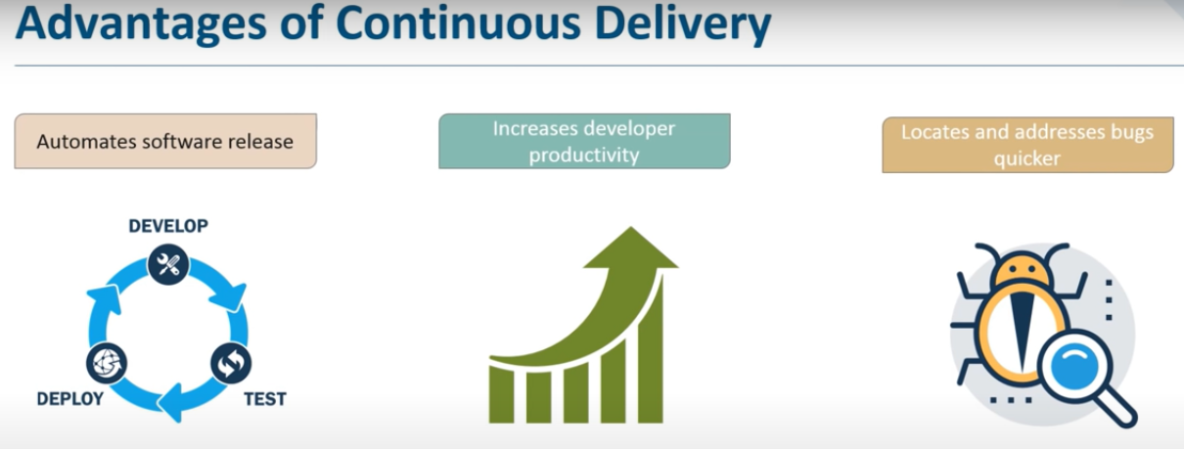

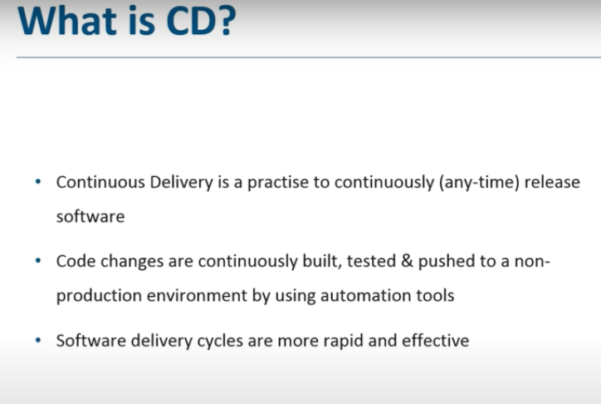

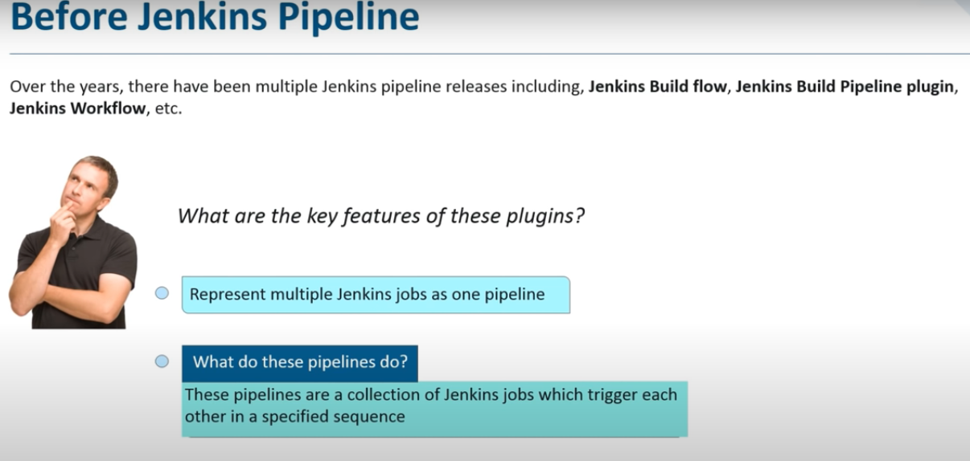

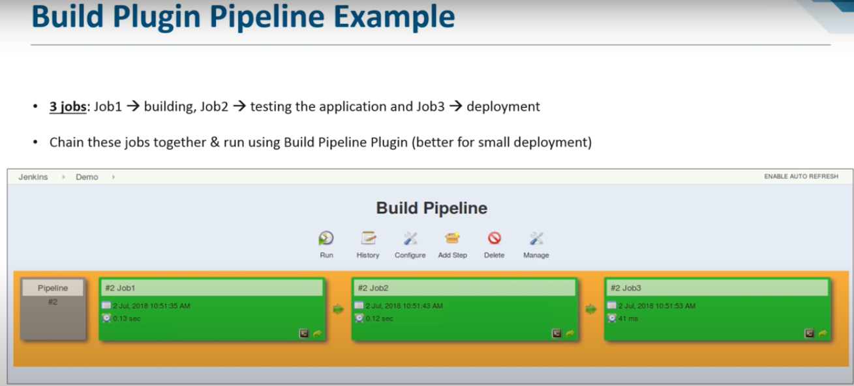

**What is Jenkins pipeline?**

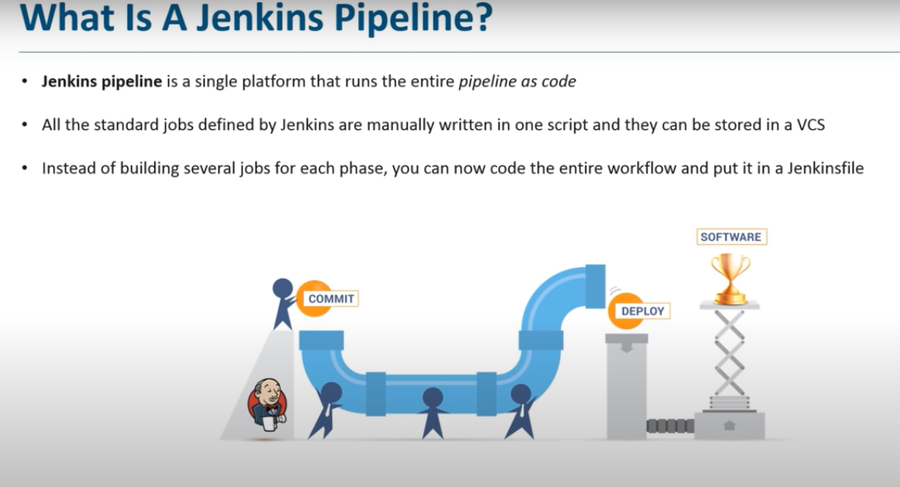

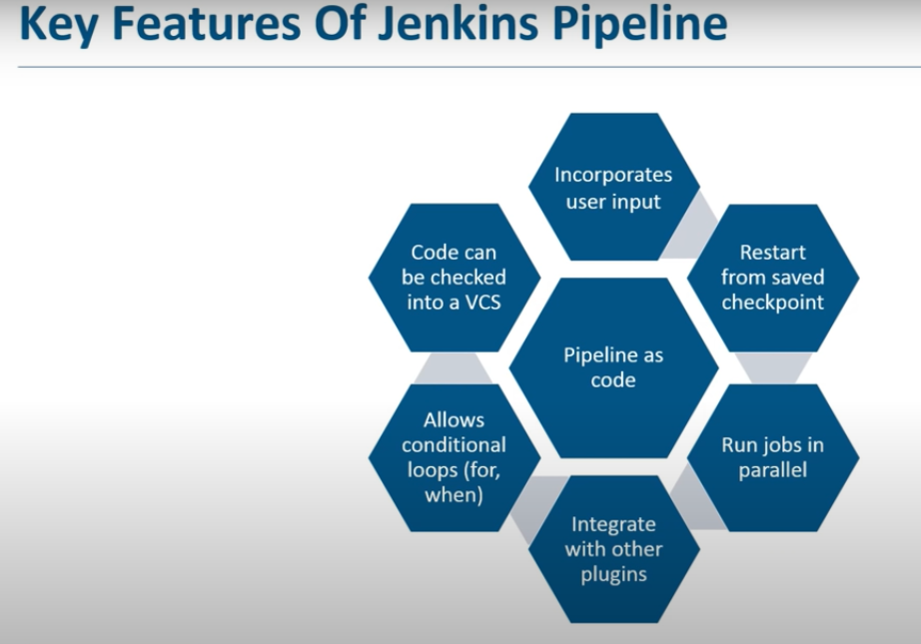

**What is Jenkinsfile?**

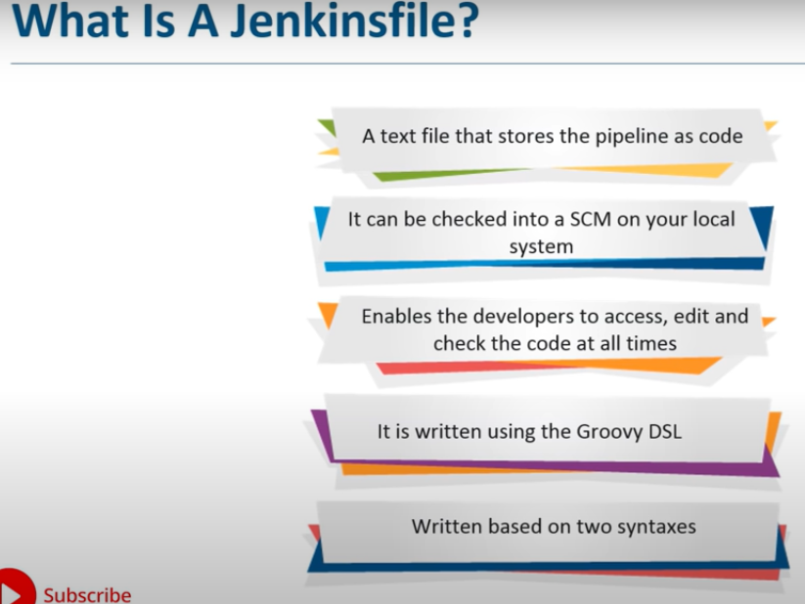

pipeline {

agent any

tools {

maven 'Maven3'

}

stages {

stage ("cloing code") {

steps{

git 'https://github.com/Lokesh-anji/hello-world-2.git'

}}

stage ("Build") {

steps{

sh "mvn clean package"

}}

}

}

=------------------------------------------------------------------------------------------------------------------------

pipeline {

agent any

environment {

PATH = "/opt/maven/apache-maven-3.6.3/bin:$PATH"

}

stages {

stage ("Git checkout") {

steps{

git ‘https://github.com/Lokesh-anji/hello-world-2.git'

}}

stage ("Maven package"){

steps {

sh "mvn clean package"

}}

}

}